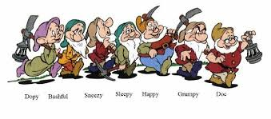

Please help Snow White
Find
The seven Dwarfs
All seven dwarfs are hiding somewhere in Craigtoun Park, can you find them?
Please write the correct letter from the map where they are!

- Bashful ……………………………………………..
- Doc…………………………………………………….
- Dopey…………………………………………………
- Grumpy……………………………………………..
- Happy………………………………………………..
- Sleepy………………………………………………..
- Sneezy……………………………………………….

Please return your completed form to the Ticket Office for a small treat.
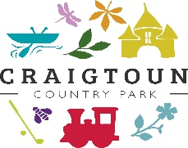
Friends of Craigtoun, Craigtoun Country Park,
St Andrews, Fife
KY16 8NX
Charity Number: SCO44249

